MIG
SAVE THIS FILE AS: U4Review2

Unit 4 Review 2b Name: ________________________

Define the following.
- What is slack:
  - if the constraint is a minimum

  - If the constraint is a maximum

- What does binding represent:
  - if the constraint is a minimum

  - If the constraint is a maximum

- When is a constraint not binding?

Answer the questions based on the Answer Report generated by Excel Solver.

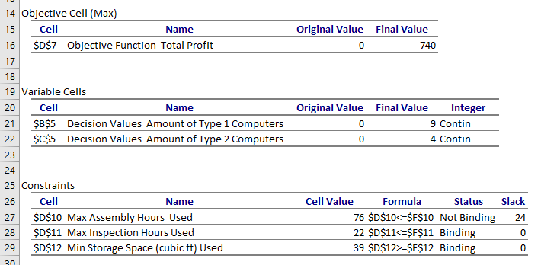
- What is the optimal solution in context of the problem? What is the maximum in context of the problem?

- Describe the binding constraints in context.

- Describe the slack on the non-binding constraints in context.
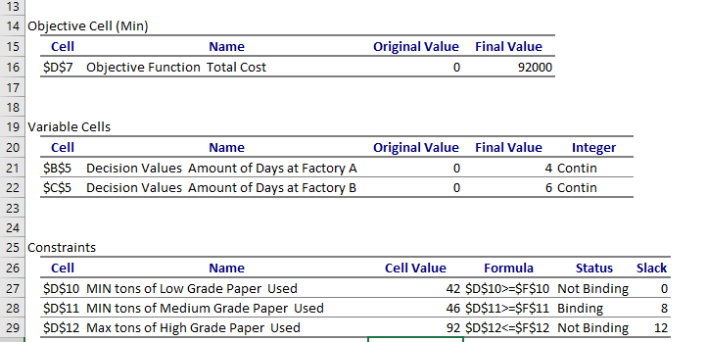

- What is the optimal solution in context of the problem? What is the minimum in context of the problem?

- Describe the binding constraints in context.

- Describe the slack on the non-binding constraints in context.

Solve the following to answer the questions. Be sure to create an Answer Report to answer the follow-up questions.
- The manager of the deli section of a grocery superstore has just learned that the department has 130 kg of mayonnaise, of which 70 kg is approaching its expiration date and must be used. To use up the mayonnaise, the manager has decided to prepare two items: a ham spread and a deli spread. Each pan of the ham spread will require 1.5 kg of mayonnaise, and each pan of the deli spread will require 2.0 kg. The manager has received an order for 12 pans of ham spread and 8 pans of the deli spread. If both spreads will cost $3 per pan to make, determine the solution that will minimize cost.
Decision Variables:

Objective Function:

Constraints:

What is the optimal solution in context of the problem? What is the minimum in context of the problem?

Describe the binding constraints in context.

Describe the slack on the non-binding constraints in context.

- Ed Silver Dog Food Company wishes to introduce a new brand of dog biscuits composed of chicken- and liver-flavored biscuits that meet certain nutritional requirements. The liver-flavored biscuits contain 1 unit of nutrient A and 2 units of nutrient B; the chicken-flavored biscuits contain 1 unit of nutrient A and 4 units of nutrient B. According to federal requirements, there must be at least 40 units of nutrient A and 60 units of nutrient B in a package of the new mix. In addition, the company has decided that there can be no more than 15 liver-flavored biscuits in a package. If it costs 1¢ to make 1 liver-flavored biscuit and 2¢ to make 1 chicken-flavored, what is the optimal product mix for a package of the biscuits to minimize the firm’s cost?
Decision Variables:

Objective Function:

Constraints:

What is the optimal solution in context of the problem? What is the minimum in context of the problem?

Describe the binding constraints in context.

Describe the slack on the non-binding constraints in context.

- You are the hospital gardener. The flowers need at least 28 pounds of nitrogen, 30 pounds of phosphates, and 4 pounds of potash to grow successfully. You have two fertilizers to use. Fertilizer A costs $4 per bag. It contains 4 pounds of nitrogen, 2 pounds of phosphates, and no potash per bag. Fertilizer B costs $5 per bag. It contains 2 pounds of nitrogen, 3 pounds of phosphates, and 1 pound of potash. How many bags of each kind of fertilizer do you use to minimize your costs?
Decision Variables:

Objective Function:

Constraints:

What is the optimal solution in context of the problem? What is the minimum in context of the problem?

Describe the binding constraints in context.

Describe the slack on the non-binding constraints in context.

