MIG

**SAVE THIS FILE AS: U2REVIEW3**

**Unit 2 Review 3** Name: ________________________

Solving LP problems with Excel

Use the SOLVER feature of Excel to find the maximum values of the objective function subject to the given constraints.

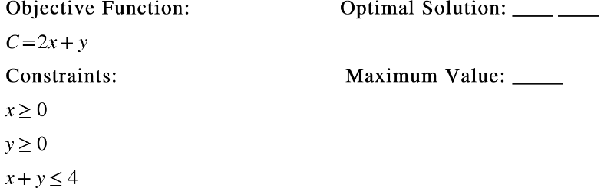1.

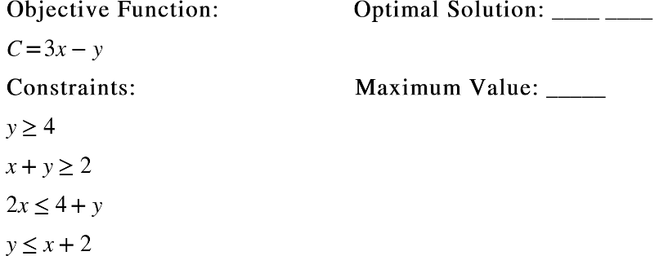

2.

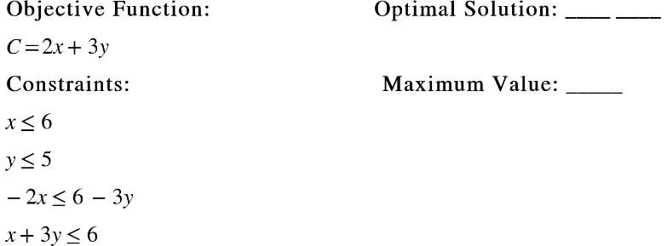

3.

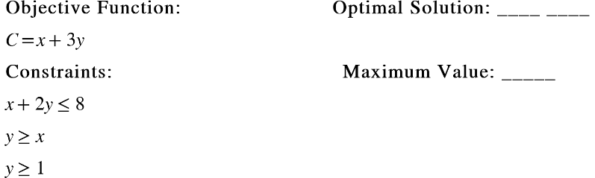4.

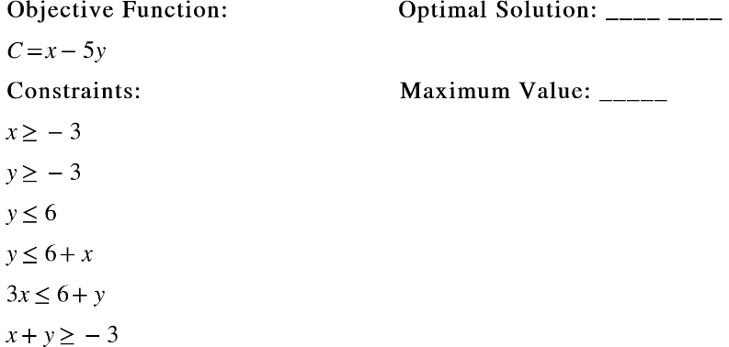5.