Chapter 10: CPM Name: _______________________________
REVIEW FOR TEST #2 Date: __________________

Complete the following dependency charts for the following digraphs. Then complete the EST, SFT, LST, LFT for the digraphs.
Activity  Code | Activity  Dependence | Completion  Time (min)
A
B
C
D
E
F
G
H
I

G
5

C
4

A
3

I
2

H
7

F
2

D
1

B
6

E
4

Activity  Code | Activity  Dependence | Completion  Time (min)
A
B
C
D
E
F
G
H

D
6

B
1

A
4

H
6

G
8

E
5

C
4

F
8

Activity  Code | Activity  Dependence | Completion  Time (min)
A
B
C
D
E
F
G
H

A
2

B
5

F
4

H
5

G
2

D
2

E
4

C
3

Activity  Code | Activity  Dependence | Completion  Time (min)
A
B
C
D
E
F
G
H
I
J
K

B
3

K
3

J
6

I
1

H
5

G
4

F
3

C
3

D
5

E
2

A
7

Create a Digraph for #5-8 AND CALCULATE THE ESTs, EFTs, LSTs, and LFTs FOR EACH NODE
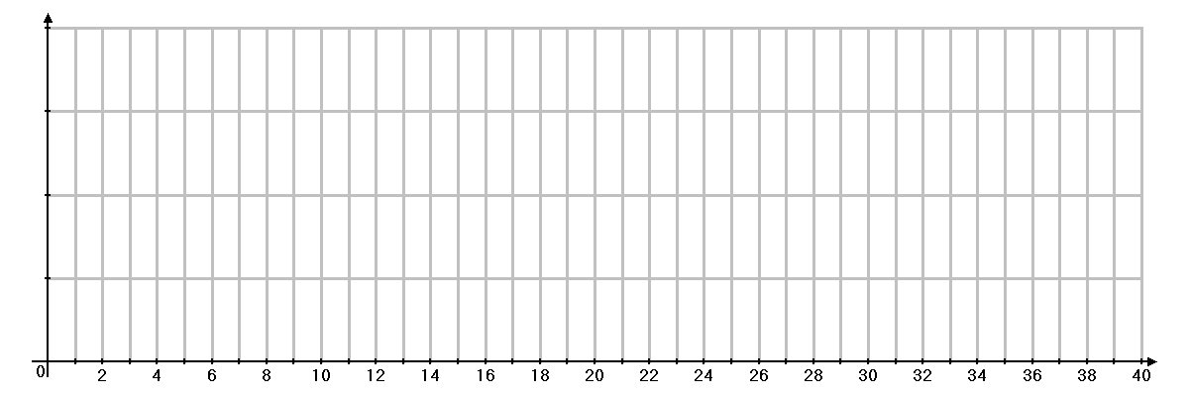
5.
A - 2
B - 2
C - 4
D - 6
Slack - 2
F - 4
G - 5
Slack -1
H - 4
E - 4
Slack - 2
I - 4

6.

A - 3
B - 2
C - 6
D - 3
Slack - 1
F - 5
G - 3
Slack -2
H - 2
E - 3
Slack - 2
I - 4
J - 2
K - 3

7.

A - 4
B - 3
C - 5
D - 3
Slack - 4
F - 2
G - 2
Slack -1
H - 4
E - 3
Slack - 2
I - 3
J - 6
K - 4
Slack -1
L - 3

8.
A - 4
B - 3
C - 2
D - 4
F - 3
G - 3
Slack -1
H - 3
E - 3
Slack - 2
I - 3
J - 2
K - 2
L - 2
Slack -1
Slack -1
Slack -1

