Chapter 10: CPM Name: _______________________________
Review for test 1 Date: __________________

- Create a Digraph for the following.

Activity  Code | Activity Description | Activity  Dependence | Completion  Time (min)
A | Jane rises, wakes Joe, starts coffee |  | 5
B | Coffee brews | A | 10
C | Joe gets up, dresses, and cooks breakfast | A | 35
D | Jane showers | A | 12
E | Jane drinks first cup of coffee | B, D | 5
F | Jane puts on makeup and dresses | E | 15
G | Jane eats breakfast and more coffee | C, F | 15
H | Jane drives to work | G | 30

- Jane’s Morning Routine Calculations
Activity | EST | LST | EFT | LFT | Slack (minutes) | Critical Activity
A
B
C
D
E
F
G
H
 |  | Critical Path: ______________________________
Project Completion Time is ___________ minutes.

Jane’s Morning Routine Extension Questions

- Determine the second most critical path of Jane’s morning routine and the slack associated with it.

- What if Jane hits the snooze bar a couple of times and Activity A’s completion time changes to 15 minutes? How does this change affect the digraph and the critical path?

- What if Jane realizes that her shirt needs to be ironed which tacks on an additional 6 minutes to Activity F? How does this change affect the digraph and the critical path?

- Create a Gantt Chart for Jane’s Morning Routine

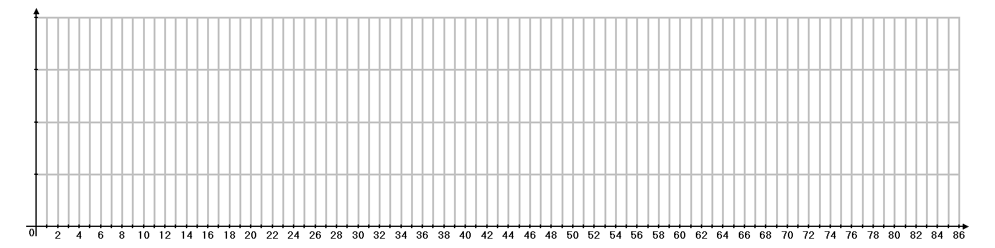

Consider the following project networks. Assume that the time required (in weeks) for each activity is a predictable constant. Find the EST, EFT, LST, LFT, then identify the critical path and draw the Gantt Chart.
A
3

B
6

C
4

D
1

E
4

F
2

G
5

H
7

I
2

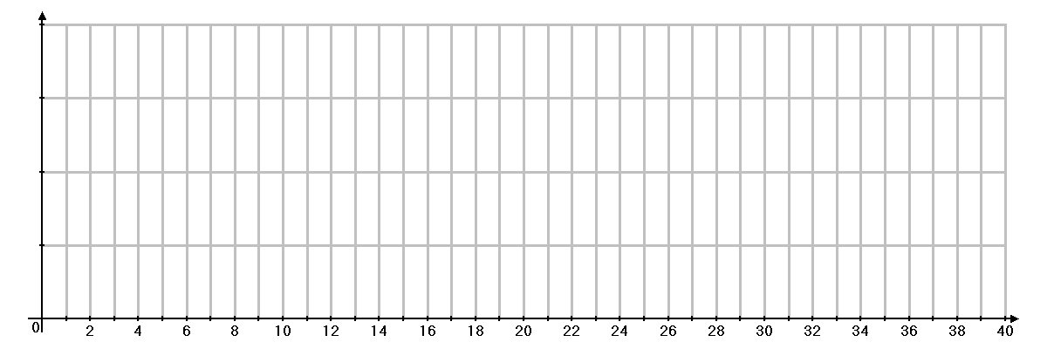

A
4

B
1

C
4

D
6

E
5

F
8

A
2

B
5

C
3

D
2

E
4

F
4

H
5

G
2

J
1

I
6

K
6

J
4

I
1

F
3

G
3

H
5

E
3

D
2

C
5

B
3

A
7

