Chapter 7: Review Name: _______________________________
Location Date: __________________
City 1
12 truckloads
Mile 15
City 3
5 truckloads
Mile 32

City 6
3 truckloads
Mile 60

City 4
12 truckloads
Mile 43

City 2
2 truckloads
Mile 25

City 5
10 truckloads
Mile 50

I. What is the total weight of the system? Where is the optimal location?

City | Weight (truckloads) | Cumulative Weight (truckloads)

II. What is the minimum total cost?

City | Mile Marker | Distance from Optimal Location (miles) | Weight (truckloads) | Cost (miles)
Minimum Total Cost

City 1
2 truckloads
Mile 5
City 3
15 truckloads
Mile 22

City 6
13 truckloads
Mile 50

City 4
9 truckloads
Mile 34

City 2
12 truckloads
Mile 15

City 5
10 truckloads
Mile 39

I. What is the total weight of the system? Where is the optimal location?

City | Weight (truckloads) | Cumulative Weight (truckloads)

II. What is the minimum total cost?

City | Mile Marker | Distance from Optimal Location (miles) | Weight (truckloads) | Cost (miles)
Minimum Total Cost

Mrs. Williams has to run several network cables between several offices and a new server whose location has yet to be determined.
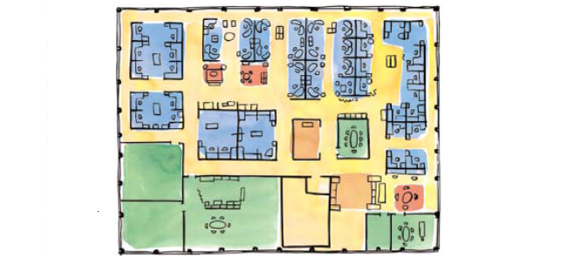
10
10
20
20
30
30
40
40
50
50
60
60
70
70
80
80
90
100
A
B
C
D
E
F
She decides to place a grid over the office and list the number of wires needed to each office.

A – 7
B – 13
C – 5
D – 4
E – 11
F – 9

Use the following tables to determine the optimal location for the new server and the total cost.

Office Location | x-coordinate | Weight  (# of wires) | Cumulative Weight  (# of wires)
Office Location | y-coordinate | Weight  (# of wires) | Cumulative Weight  (# of wires)

Office Location | Distance from Optimal Location | Weight  (# of wires) | Cost  (feet of wire used)

Where should the new server be located?

What will be the total amount of wire needed?

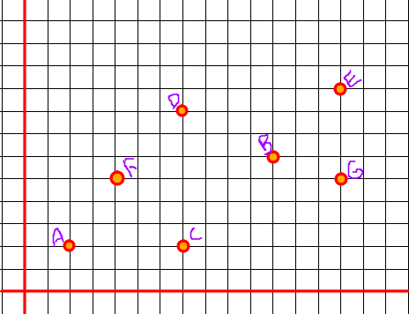
Weights
A: 3 visits
B: 7 visits
C: 5 visits
D: 10 visits
E: 2 visits
F: 4 visits
G: 3 visits

Location | x-coordinate | Weight | Cumulative Weight
Location | y-coordinate | Weight | Cumulative Weight

Office Location | Distance from Optimal Location | Weight  (# of wires) | Cost  (feet of wire used)

What is the optimal location?

What will be the total cost?

3 friends live in Richmond Hill, Dublin, and Homerville. They decide to find a central location to meet for lunch. They are wondering if Jesup would be a central location. Using mathematical terminology (vocabulary) explain why or why not Jesup is a good location. Answer should be in complete sentences.

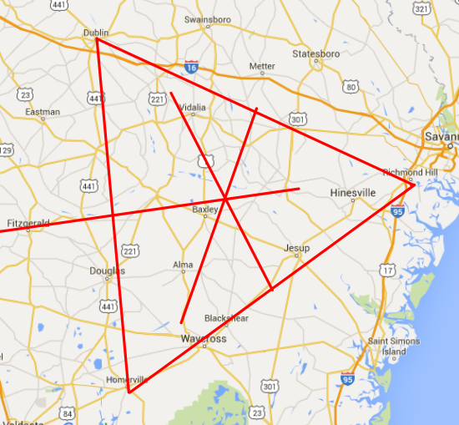
_______________________________________

_______________________________________

_______________________________________

_______________________________________

_______________________________________

_______________________________________

_______________________________________

_______________________________________

_______________________________________

__________________________________________________________________________________

__________________________________________________________________________________

__________________________________________________________________________________

__________________________________________________________________________________

__________________________________________________________________________________

__________________________________________________________________________________
1. Define Rectilinear distance.

2. What is a median location?

3. What is weight?

4. What is one dimension? What is two dimensions?

5. There will be one linear programming problem that will be solved in a series of multiple choice questions. Be prepared. Review decision variables, objective function, constraints, and the steps we go through to solve linear programming problems.

