Chapter 7: Location Name: _______________________________
  - Ellie’s Eco-Smoothies (2-D) Location Date: __________________

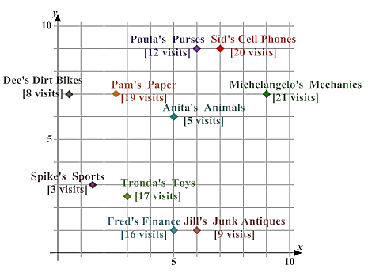
- Determining the optimal location.
Office | x-coordinate | Weight (visits) | Cumulative Weight

Office | y-coordinate | Weight (visits) | Cumulative Weight

- What is the total weight of the system?

- What is the median weight of the system?

- Where is the optimal location?

Office | Rectilinear Distance from Optimal Location (city blocks) | Weight (visits) | Cost (city blocks)
Anita’s Animal |  | 5
Dee’s Dirt Bikes |  | 8
Fred’s Finance |  | 16
Jill’s Junk Antiques |  | 9
Michelangelo’s Mechanics |  | 21
Pam’s Paper |  | 19
Paula’s Purses |  | 12
Sid’s Cell Phones |  | 20
Spike’s Sports |  | 3
Tronda’s Toys |  | 17
Minimum Total Cost:

- What would be the total block driven to visit all the locations?

- Mrs. Williams has to pick up several items for her daughter’s sweet sixteen party at various locations. She wants to locate a parking space downtown such that she can get to all the stores in a minimum amount of time without reparking. Each block is square, 100 feet on a side. Streets running north to south are numbered consecutively. Those running east to west are lettered consecutively. The bakery is at 6th and E; she must walk half as fast as normal from the bakery so that she won’t drop the birthday cake. At 10th and D is the grocery store. The dress shop is at 12th and G. Mrs. Williams picks up her daughter, Cecilia, from the hair salon at 10th and G and they walk twice as fast as normal back to the car so that the wind doesn’t mess up her hair. It is assumed she must stay on the sidewalks that enclose each block- distance used crossing streets is considered negligible. It is also assumed that she must return to the car after visiting each store before visiting the next one.

- Construct a grid to represent this problem situation.
- Determine the location of the parking space that satisfies her objective taking note of all assumptions you make in formulating your decision.
- What is the distance from each shop to the parking space?
- How did the walking speeds influence your solution?

- USC University Hospital (H1), Cedars Sinai Medical Center (H2), Olympia Medical Center (H3), and California Hospital (H4) are all located in the Los Angeles area. They are cooperating to establish a centralized blood-bank facility that will serve all four hospitals. The new facility is to be located such that distance traveled is minimized. The hospitals are located as follows: H1 = (5, 10), H2 = (7, 6), H3 = (4, 2), and H4 = (16, 3). The number of deliveries to be made per year between the blood-bank facility and each hospital is estimated to be 450, 1,200, 300, and 1,500, respectively. Assuming rectilinear travel, determine the optimum location of the blood-bank facility.

- Draw a graph and plot the locations of the four hospitals. Label each hospital with its respective weight.
- What is the median location?

- What is the x-coordinate for the optimal location of the blood-bank facility?

- What is the y-coordinate for the optimal location of the blood-bank facility?

- Calculate the distance from each hospital to the blood-bank facility and using these distances and the respective weights, calculate the total travel cost of this system.

- What assumption must be made concerning the deliveries of blood?
- Is it reasonable to expect delivery trips will always be to only one hospital when a delivery is made?

