MIG
Unit 9 Prerequisite 1 Name: ________________________
Critical Path Method
A simple activity to plan is making dinner for your family. You recruit three of your friends to help you prepare a meal to share. They agree to help because they will get a free meal. In this section we will explore the time that will be needed to create this meal and the different tasks that will be going on simultaneously to make this meal a success.
Activity Code | Activity Description | Activity Dependence | Completion Time (minutes)
A | Find recipe for taco salad on Internet | None | 5
B | Find recipe for dessert in Mom’s recipe box | None | 6
C | Make graham cracker crust | B | 4
D | Clean lettuce | A | 3
E | Find cheese in refrigerator | A | 1
F | Shred cheese | E | 4
G | Brown hamburger and assemble tacos (including cheese) | D, F | 14
H | Prepare the pudding | B | 8
I | Assemble the pudding pie | C, H | 4
J | Put out all the food for dinner | G, I | 2

ON A SEPARATE PIECE OF PAPER draw a di-graph to represent this situation.
Be sure to highlight the critical path.

Fill in the following table for the slack time for the activities in the family dinner problem.
Activity | EST | LST | EFT | LFT | Slack | Critical Activity
A
B
C
D
E
F
G
H
I
J

Critical Path: _________________________

Project Completion Time: ______________
Gantt chart
Use the information from the problem to develop a Gantt chart
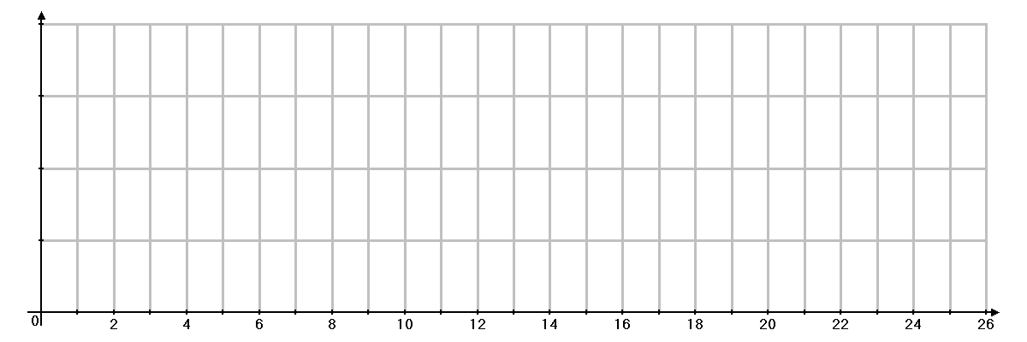

Paths
List all of the paths along with the slack time associated with each.
PATHS | SLACK

