**Linear Programming Using Excel**

**Part 1: Installing the Solver Add-In**

**Part 2: Setting Up the Problem on the Spreadsheet**

**Part 3: Using the Solver to Solve the Problem**

**Part 1: Installing the Solver Add-In**



**1.** In Microsoft Excel, click on **File**, then click **Options** and click **Add-ins**

**2.** In the Add-Ins box, select **Solver Add-In** and click **Go**...



**3.** In the Add-Ins available box, ***check*** the Solver Add-in and then **OK**. *Make sure there is a check mark in the box!*

***Example Problem***

Decision Variables:

x = # of cups

y = # of plates

**Objective Function: 2*x* + 1.5*y* = Total Profit**

**Constraints:**

**Time 6*x* + 3*y* < 1200**

**Clay 0.75*x* + 1*y* < 250**

**Part 2: Setting Up the Problem on the Spreadsheet**

1. Enter the coefficients of the objective function *i(for this example enter 2 and 1.5))* in cells **B8** and **C8**.
2. Enter the coefficients of the Constraint-1 *i(for this example, enter 6 and 3))* in cells **B11**, **C11** and the right hand side of the inequality  *(for this example enter 1200))* in cell **F11**.
3. Enter the coefficients of the Constraint-2 *i(for this example, enter 0.75 and 1))* in cells **B12**, **C12** and the right hand side of the inequality *i(for this example, enter 250))* in cell **F12**.

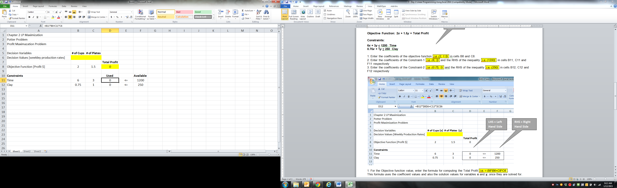

***NOTE: These values are not 0. They are formulas that are described at the bottom of this page.***

***NOTE: These values are not 0. They are formulas that are described at the bottom of this page.***

***NOTE: These values are not 0. They are formulas that are described at the bottom of this page.***

**FORMULAS TO BE ENTERED FOR THE TOTAL PROFIT AND USED**

1. For the Objective function value, enter the formula for computing the Total Profit *iThe formula is**=* ***B8*B6+C8*C6*** .

This formula uses the coefficient values and also the solution values for variables **x** and **y**, once they are solved for.

2. Similarly enter the formula for left hand side of the Constraint 1 in **D11**  *=* ***B11*B6+C11*C6***

&Constraint 2 in **D12** *I =* ***B12*B6+C12*C6***

**Now Excel Solver will be used, in the Data tab click Solver.**

**The solver box appears as follows.**

Now Excel Solver will be used, in the **Data** tab click **Solver**.

The solver box appears as follows.

**Part 3: Using the Solver to Solve the Problem**

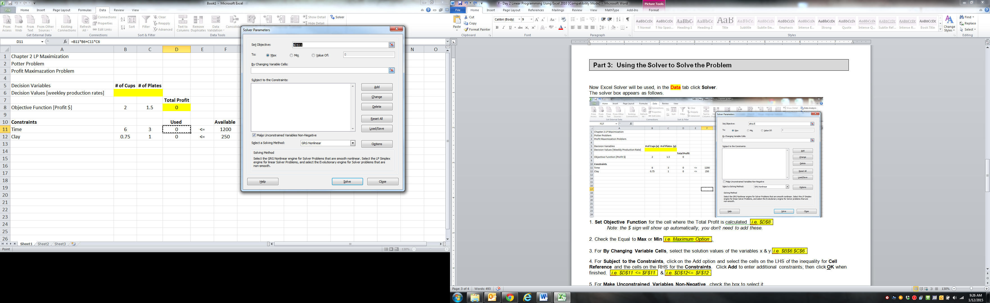

**This is where the MAX. OR MIN. VALUE will be calculated by the solver.**

1. **Set Objective** Function for the cell where the Total Profit is calculated. *Iselect cell* ***D8****8*

**This is where the OPTIMAL SOLUTION will be calculated**

*Note: the $ sign will show up automatically, you don’t need to add these.*

1. Check the Equal to **Max** or **Min** *iSelect the Maximum Optionn*.
2. For **By Changing Variable Cells**, select the solution values of the variables x & y *t****Select cells B6****:****C66***
3. For **Subject to the Constraints**, click on the **Add** option and select the cells on the left hand side of the inequality for **Cell Reference** and the cells on the right hand side for the **Constraints**. Click **Add** to enter additional constraints; then click **OK** when finished. *iSelect* ***D11*** *<=* ***F111*** & *iSelect* ***D12*** *<=* ***F122***
4. Finally, for **Select a Solving Method**, **ALWAYS** click the dropdown arrow and select **Simplex LP**.

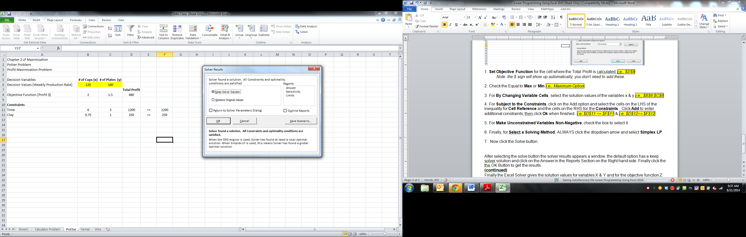

1. Now click the **Solve** button.

After selecting the solve button the solver results appears a window, the default option has a **Keep**

**Solver Solution**. Finally click the

the **OK** Button to get the results.