**What does the Empirical Rule Apply to?**

Under certain conditions, those you will discover during this activity, the Empirical Rule can applied to a certain type of distribution.

**The Empirical Rule is as follows:**

For certain conditions (*which you will discover in this activity*),

* **68% of the data will be located within one standard deviation symmetric to the mean**
* **95% of the data will be located within two standard deviations symmetric to the mean**
* **99.7% of the data will be located within three standard deviations symmetric to the mean**

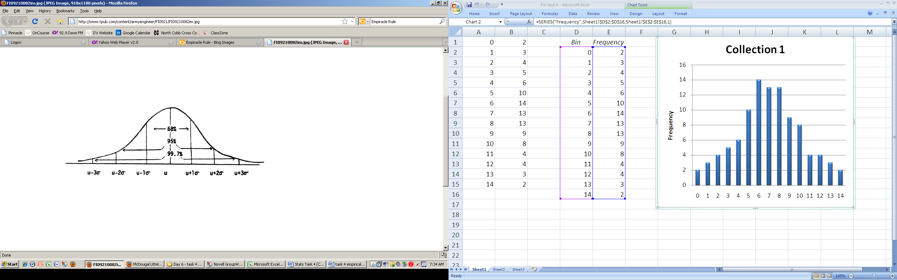

For each of the dotplots below, use your calculator to determine the mean and standard deviation of each of the distributions. Then, determine how many dots there are between the first standard deviation above and below the mean (round your *µ* and *σ* to the nearest whole number when dealing with these dotplots).

**Your goal is to determine what types of distributions the Empirical Rule should apply**.

For your convenience, there are 100 data points for each dotplot.

* Mean :____________
* Standard Deviation :_________
* Calculate the following:
  +  and 
  +  and 
  +  and 
* Locate these numbers on the dotplot above and determine how many dots are between these values. ____ ____ ____





2

* Mean :____________
* Standard Deviation :_________
* Calculate the following:
  +  and 
  +  and 
  +  and 
* Locate these numbers on the dotplot above and determine how many dots are between these values. ____ ____ ____

* Mean :____________
* Standard Deviation :_________
* Calculate the following:
  +  and 
  +  and 
  +  and 
* Locate these numbers on the dotplot above and determine how many dots are between these values. ____ ____ ____



3

* Mean :____________
* Standard Deviation :_________
* Calculate the following:
  +  and 
  +  and 
  +  and 
* Locate these numbers on the dotplot above and determine how many dots are between these values. ____ ____ ____



4



5

* Mean :____________
* Standard Deviation :_________
* Calculate the following:
  +  and 
  +  and 
  +  and 
* Locate these numbers on the dotplot above and determine how many dots are between these values. ____ ____ ____
* Mean :____________
* Standard Deviation :_________
* Calculate the following:
  +  and 
  +  and 
  +  and 
* Locate these numbers on the dotplot above and determine how many dots are between these values. ____ ____ ____



6

* Mean :____________
* Standard Deviation :_________
* Calculate the following:
  +  and 
  +  and 
  +  and 
* Locate these numbers on the dotplot above and determine how many dots are between these values. ____ ____ ____



7

* Mean :____________
* Standard Deviation :_________
* Calculate the following:
  +  and 
  +  and 
  +  and 
* Locate these numbers on the dotplot above and determine how many dots are between these values. ____ ____ ____



8

Which distributions had close to 68%, 95% and 99.7% of the data within one, two and three standard deviation of the mean?

What do they have in common?

For which type of distributions do you think the Empirical rule applies?