Prerequisite 3 Name:__________________________
- A few months ago, Super Star Sam picked up a new Iphone 6S. As he was listening to it on the train Tuesday, he wondered how much longer his battery will last. After a quick online search, he discovered that the expected battery life for a 6S is 400 full charges with a standard deviation of 25 and the distribution is Normally distributed.

- What percent of the 6Ss can recharge at least 450 times?

- What percent of the 6Ss can recharge less than 325 times?

- In a box of 200 6Ss, how many of those are likely to recharge between 350 and 475 times?

- The mean gas mileage for cars driven by the students at North Cobb High School is 30 miles per gallon, and the standard deviation is 4 miles per gallon. Assume that the gas mileages are normally distributed. Today there are 350 cars in the parking lot.

- How many of the cars have gas mileages between 22 and 34 miles per gallon?

- How many of the cars have gas mileages greater than 34 miles per gallon?

- How many of the cars will have a gas mileage of at most 26 miles per gallon?

- A person’s blood glucose level and diabetes are closely related. After a 12-hour fast, the random variable x will have a distribution that is approximately Normal with a mean of 85 and standard deviation of 25 for people under the age of 50.

- What percentage of people under 50 have a blood glucose level less than 60 milligrams per deciliter?

- What percent have a blood glucose level greater than 10 milligrams per deciliter?

- What percent having a blood glucose level greater than 135 milligrams per deciliter (borderline diabetes starts at 140)?

- What percent of the population has a blood glucose level between 85 and 135 milligrams per deciliter?

- If I survey 2000 people under 50, how many are likely to have a blood glucose level less than 110 milligrams per deciliter?

- The quality control inspector for a bagel shop periodically checks the calorie content of the bagels. The inspector has determined that the multi-grain bagels have a mean of 300 calories and a standard deviation of 10 calories. The inspector has determined that the calories are normally distributed.

a. What percent of the multi-grain bagels have a caloric content between 270 and 330?

b. What percent of the multi-grain bagels have a caloric content within two standard deviations of the mean?

c. If the inspector grabs 523 bagels, how many are likely to have a caloric content at least 280 calories?

- The response times for a certain ambulance company are normally distributed, with a mean of 12 minutes. Ninety-five percent of the response times are between 8 and 16 minutes.

a. What is the standard deviation of the response times?

b. What percent of the response times are longer than 18 minutes?

- North Cobb had 500 juniors took the ACT last year. The scores are distributed normally with a mean of 24 and a standard deviation of 4. Label the graph and fill in the percentages.
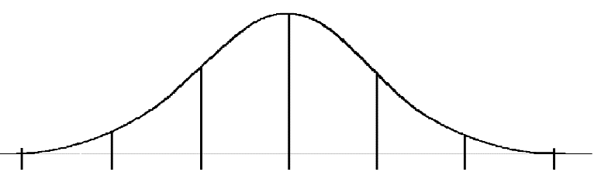

- What percentage of scores are between 20 and 28?

- What percentage of scores is greater than a score of 24?

- Approximately how many juniors scored between 24 and 28?

- Approximately how many juniors scored higher than 32?

