MIG Unit 4 Test Prep Name_________________________________
Define the following.
- Slack –

- Binding –

- Not Binding –

- Optimal Solution -

- Maximum or Minimum value –

Answer the questions based on the Answer Report generated by Excel Solver.

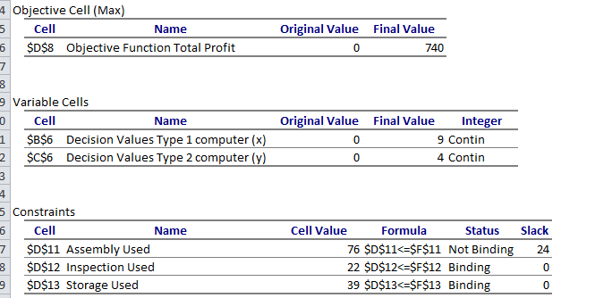

- What is the optimal solution in context of the problem? What is the maximum in context of the problem?

- Which constraints are binding (include context)? Explain why they were binding?

- Which constraints are NOT binding (include context)? Explain what the slack REPRESENTS in the context of the problem.
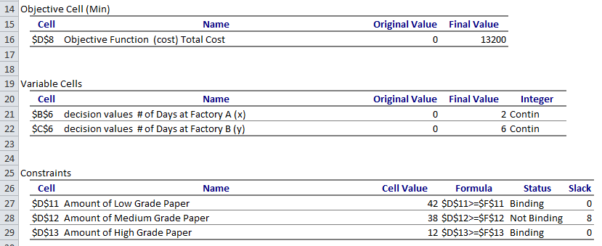

- What is the optimal solution in context of the problem? What is the maximum in context of the problem?

- Which constraints are binding (include context)? Explain why they were binding?

- Which constraints are NOT binding (include context)? Explain what the slack REPRESENTS in the context of the problem.

Solve the following to answer the questions. Be sure to create an Answer Report to answer the followup questions.

- Two dietary drinks are used to supply protein and carbohydrates. The Drink A provides 1 unit of protein and 3 units of carbohydrates in each liter. The Drink B supplies 2 units of protein and 2 units of carbohydrates in each liter. An athlete requires at least 3 units of protein and 5 units of carbohydrates. Find the amount of each drink the athlete should consume to minimize the cost and still meet the minimum dietary requirements. Drink A costs $2 per liter and Drink B costs $3 per liter.
Decision Variables: Constraints:
Objective Function:

What is the optimal solution in context of the problem? What is the maximum in context of the problem?

Which constraints are binding (include context)? Explain why they were binding?

Which constraints are NOT binding (include context)? Explain what the slack REPRESENTS in the context of the problem.

- A small petroleum company owns two refineries. Refinery 1 costs $20,000 per day to operate, and it can produce 400 barrels of high-grade oil, 300 barrels of medium-grade oil, and 200 barrels of low-grade oil each day. Refinery 2 is newer and more modern. It costs $25,000 per day to operate, and it can produce 300 barrels of high-grade oil, 400 barrels of medium-grade oil, and 500 barrels of low-grade oil each day. The company has orders totaling 25,000 barrels of high-grade oil, 27,000 barrels of medium-grade oil, and 30,000 barrels of low-grade oil. How many days should it run each refinery to minimize its costs and still refine enough oil to meet its orders?
Decision Variables: Constraints:
Objective Function:

What is the optimal solution in context of the problem? What is the maximum in context of the problem?

Which constraints are binding (include context)? Explain why they were binding?

Which constraints are NOT binding (include context)? Explain what the slack REPRESENTS in the context of the problem.

- You are the hospital gardener. The flowers require 28 pounds of nitrogen, 30 pounds of phosphates, and 4 pounds of potash. You have two fertilizers to use. One kind costs $4 per bag. It contains 4 pounds of nitrogen, 2 pounds of phosphates, and no potash per bag. The other kind costs $5 per bag. It contains 2 pounds of nitrogen, 3 pounds of phosphates, and 1 pound of potash. How many bags of each kind of fertilizer do you use to minimize your costs?
Decision Variables: Constraints:
Objective Function:

What is the optimal solution in context of the problem? What is the maximum in context of the problem?

Which constraints are binding (include context)? Explain why they were binding?

Which constraints are NOT binding (include context)? Explain what the slack REPRESENTS in the context of the problem.

